**REAL TIME INFORMATION DISSEMINATION ON VEHICLE ACCIDENT**

**ABSTRACT:**

This paper presents STEID, a spatio-temporal emergency information dissemination protocol for vehicular networks. Its main goal is to quickly disseminate traffic alerts about accidents or congestions to every car that passes through an emergency zone during the lifetime of the emergency. To achieve this goal, we propose a hybrid network architecture consisting of WiFi clusters connected through proxy servers and cellular links. STEID executes on top of this architecture and ensures the emergency message delivery to all the intended vehicles in a short time interval. Simulations conducted with hundreds of vehicles moving at speeds between 45mph and 70mph demonstrate this fact. We also compare STEID to a solution using only cellular communication with a central server for information dissemination. The results indicate that the average delay for STEID is between two and four times less than the one for cellular-only approach for regular highway speeds, while the traffic load imposed on the cellular network decreases by more than 65%.

**INTRODUCTION:**

In recent years, most new vehicles come equipped with GPS receivers and navigation systems. Car makers such as Ford, GM, and BMW have already announced efforts to include significant computing power inside their cars [2], [13]. We envision that in the near future the number of vehicles equipped with computing technologies and wireless network interfaces will increase dramatically. These vehicles will be capable to run network protocols that will exchange messages for safer and more fluid traffic on the roads. Avoiding accidents and traffic jams are two main immediate benefits of vehicular networks. For instance, most drivers would like to receive real-time alerts about accidents happening at a short distance in front of their vehicles at night, in the fog, or heavy rain. This type of accidents could lead to collision chains involving tens of vehicles. Although not life-threatening, traffic jams are huge nuisances. The ability to receive an alert about a potential traffic jam would allow drivers to take alternate routes, saving both time and fuel. The problem addressed in this paper is: How to ensure that a traffic emergency message is disseminated with high probability and low delay to all the potentially affected vehicles? If we assume that participating vehicles (not all moving vehicles) are equipped with an embedded computer, a GPS receiver, navigation software, and one or multiple wireless network interfaces, the problem can be reduced to designing a ∗This work is supported in part by the NSF grant CNS-0520033. reliable and efficient safety information dissemination protocol in vehicular networks. To understand the requirements for such a protocol, let us consider the scenario illustrated in Figure 1. When an accident or other event (e.g., road work) susceptible to lead to traffic congestion happens, a traffic alert message is generated. Such a message is either triggered automatically by a car involved in an accident (e.g., a sensor for inflated airbags could generate an event propagated to the embedded computer through the on-board diagnostic system interface), by a person (driver, road worker, or police officer) or by a system capable of detecting/predicting traffic jams. Such an alert is characterized by: • the location of the emergency, defined as a pair of road and relative position of the emergency on that road. • the emergency zone or alert region, defined as all the roads leading to the emergency location. • the lifetime of the emergency, defined as the time needed to return to regular traffic conditions after an emergency. These characteristics are determined by applications running on vehicles. Let τmax be the maximum safest delay in delivering the message to a vehicle. This value could be the average time it would take a vehicle to move from the entry of the alert zone to the nearest exit (to avoid traffic congestion). If the dissemination protocol ensures that every vehicle already in the zone or every new vehicle entering the zone during the emergency lifetime receives the alert within τmax seconds, we say that the protocol provides both spatial and temporal reliability as defined below.

Spatial Reliability: A protocol provides spatial reliability if the alert is delivered to all participating vehicles within the emergency zone. Temporal Reliability: A protocol provides temporal reliability if a participating vehicle does not spend more than τmax time within the emergency zone before receiving the alert. For instance, spatial reliability means that all vehicles present in the alert region in Figure 1.a must receive the alert. Figure 1.b helps us to understand temporal reliability; vehicles G, I, and H, which entered the zone after the accident happened, must receive the alert before reaching the nearest exit. This paper presents the Spatio-Temporal Information Dissemination protocol (STEID), a protocol that addresses both the spatial reliability and the temporal reliability requirements. STEID ensures timely delivery of alert messages to all the

**OBJECTIVE:**

The main objective of this dissertation is to present a system of an anytime-anywhere traffic information dissemination system. The system collects traffic information that is sensed by the individual drivers, mobile and smart phone sensors, social networks and integrates it with traffic information obtained from deployed ITS technologies and emerging ITS technologies. The system analyses all gathered information and disseminates the information to individual driver’s based on the relevancy of the information to each driver. In addition to that, it utilize theis traffic information to provide the drivers with optimized routes.

**BLOCK DAIGRAM:**

ARDUINO

GSM

Smoke sensor

CLOUD

GPS

Tilt sensor

Vibration

sensor

WI-FI

Power supply

**RECEIVER:**

ANDROID MOBILE

BLYNK APP

**COMPONENTS REQUIRED:**

**Hardware:**

1.Arduino Microcontroller

2.Gas sensor

3.Vibration sensor

4.GSM Modem

5.GPS Module

6.Power supply

**Software:**

1.Arduino IDE

**WORKING METHODLOGY:**

In this proposed method we have used Arduino microcontroller which is the heart of the project. It control the all function of the device namely Smoke sensor, Tilt sensor, Vibration sensor, GSM, GPS.

As soon as the smoke has occurred in the environment then smoke sensor will detect the smoke then comparator will compare actual voltage & threshold voltage if any difference is there then the sensor send signal to controller similarly Tilt sensor which is used to tilting of the object then send signal to controller similarly vibration has occurred then then the vibration sensor send signal to controller then corresponding alert message has been send to receiver side which is in blynk app through the wi-fi internet. Similarly send location to the android mobile through the blynk app.

**Arduino:**

**Overview**

Arduino is an open-source electronics platform based on easy-to-use hardware and software. [Arduino boards](https://www.arduino.cc/en/Main/Products) are able to read inputs - light on a sensor, a finger on a button, or a Twitter message - and turn it into an output - activating a motor, turning on an LED, publishing something online. You can tell your board what to do by sending a set of instructions to the microcontroller on the board. To do so you use the [Arduino programming language](https://www.arduino.cc/en/Reference/HomePage) (based on [Wiring](http://wiring.org.co/)), and [the Arduino Software (IDE)](https://www.arduino.cc/en/Main/Software), based on [Processing](https://processing.org/).

Over the years Arduino has been the brain of thousands of projects, from everyday objects to complex scientific instruments. A worldwide community of makers - students, hobbyists, artists, programmers, and professionals - has gathered around this open-source platform, their contributions have added up to an incredible amount of [accessible knowledge](http://forum.arduino.cc/) that can be of great help to novices and experts alike.

Arduino was born at the Ivrea Interaction Design Institute as an easy tool for fast prototyping, aimed at students without a background in electronics and programming. As soon as it reached a wider community, the Arduino board started changing to adapt to new needs and challenges, differentiating its offer from simple 8-bit boards to products for IoT applications, wearable, 3D printing, and embedded environments. All Arduino boards are completely open-source, empowering users to build them independently and eventually adapt them to their particular needs. The [software](https://www.arduino.cc/en/Main/Software), too, is open-source, and it is growing through the contributions of users worldwide.

Arduino is a computer hardware and software company, project, and user community that designs and manufactures [microcontroller](https://en.wikipedia.org/wiki/Microcontroller) kits for building digital devices and interactive objects that can sense and control objects in the physical world. The project's products are distributed as [open-source hardware](https://en.wikipedia.org/wiki/Open-source_hardware) and [software](https://en.wikipedia.org/wiki/Open-source_software), which are licensed under the [GNU Lesser General Public License](https://en.wikipedia.org/wiki/GNU_Lesser_General_Public_License) (LGPL) or the [GNU General Public License](https://en.wikipedia.org/wiki/GNU_General_Public_License) (GPL),[[1]](https://en.wikipedia.org/wiki/Arduino#cite_note-1) permitting the manufacture of Arduino boards and software distribution by anyone. Arduino boards are available commercially in preassembled form, or as [do-it-yourself](https://en.wikipedia.org/wiki/Do-it-yourself) kits.

The project's board designs use a variety of microprocessors and controllers. These systems provide sets of digital and analog [input/output](https://en.wikipedia.org/wiki/Input/output) (I/O) pins that may be interfaced to various expansion boards ("shields") and other circuits. The boards feature serial communications interfaces, including Universal Serial Bus ([USB](https://en.wikipedia.org/wiki/USB)) on some models, for loading programs from personal computers. The microcontrollers are mainly programmed using a dialect of features from the programming languages [C](https://en.wikipedia.org/wiki/C_(programming_language)) and [C++](https://en.wikipedia.org/wiki/C%2B%2B). In addition to using traditional compiler toolchains, the Arduino project provides an [integrated development environment](https://en.wikipedia.org/wiki/Integrated_development_environment) (IDE) based on the [Processing](https://en.wikipedia.org/wiki/Processing_(programming_language)) language project.

The Arduino project started in 2005 as a program for students at the [Interaction Design Institute Ivrea](https://en.wikipedia.org/wiki/Interaction_Design_Institute_Ivrea) in [Ivrea](https://en.wikipedia.org/wiki/Ivrea), Italy,[[2]](https://en.wikipedia.org/wiki/Arduino#cite_note-kushner-2) aiming to provide a low-cost and easy way for novices and professionals to create devices that interact with their environment using [sensors](https://en.wikipedia.org/wiki/Sensor) and [actuators](https://en.wikipedia.org/wiki/Actuator). Common examples of such devices intended for beginner hobbyists include simple [robots](https://en.wikipedia.org/wiki/Robot), [thermostats](https://en.wikipedia.org/wiki/Thermostat), and [motion detectors](https://en.wikipedia.org/wiki/Motion_detector).

Arduino/Genuino Uno is a microcontroller board based on the ATmega328P ([datasheet](http://www.atmel.com/Images/doc8161.pdf)). It has 14 digital input/output pins (of which 6 can be used as PWM outputs), 6 analog inputs, a 16 MHz quartz crystal, a USB connection, a power jack, an ICSP header and a reset button. It contains everything needed to support the microcontroller; simply connect it to a computer with a USB cable or power it with a AC-to-DC adapter or battery to get started.. You can tinker with your UNO without worring too much about doing something wrong, worst case scenario you can replace the chip for a few dollars and start over again.

"Uno" means one in Italian and was chosen to mark the release of Arduino Software (IDE) 1.0. The Uno board and version 1.0 of Arduino Software (IDE) were the reference versions of Arduino, now evolved to newer releases. The Uno board is the first in a series of USB Arduino boards, and the reference model for the Arduino platform; for an extensive list of current, past or outdated boards see the Arduino index of boards.

### Why Arduino?

Thanks to its simple and accessible user experience, Arduino has been used in thousands of different projects and applications. The Arduino software is easy-to-use for beginners, yet flexible enough for advanced users. It runs on Mac, Windows, and Linux. Teachers and students use it to build low cost scientific instruments, to prove chemistry and physics principles, or to get started with programming and robotics. Designers and architects build interactive prototypes, musicians and artists use it for installations and to experiment with new musical instruments. Makers, of course, use it to build many of the projects exhibited at the Maker Faire, for example. Arduino is a key tool to learn new things. Anyone - children, hobbyists, artists, programmers - can start tinkering just following the step by step instructions of a kit, or sharing ideas online with other members of the Arduino community.

There are many other microcontrollers and microcontroller platforms available for physical computing. Parallax Basic Stamp, Netmedia's BX-24, Phidgets, MIT's Handyboard, and many others offer similar functionality. All of these tools take the messy details of microcontroller programming and wrap it up in an easy-to-use package. Arduino also simplifies the process of working with microcontrollers, but it offers some advantage for teachers, students, and interested amateurs over other systems:

* **Inexpensive** - Arduino boards are relatively inexpensive compared to other microcontroller platforms. The least expensive version of the Arduino module can be assembled by hand, and even the pre-assembled Arduino modules cost less than $50
* **Cross-platform** - The Arduino Software (IDE) runs on Windows, Macintosh OSX, and Linux operating systems. Most microcontroller systems are limited to Windows.
* **Simple, clear programming environment** - The Arduino Software (IDE) is easy-to-use for beginners, yet flexible enough for advanced users to take advantage of as well. For teachers, it's conveniently based on the Processing programming environment, so students learning to program in that environment will be familiar with how the Arduino IDE works.
* **Open source and extensible software** - The Arduino software is published as open source tools, available for extension by experienced programmers. The language can be expanded through C++ libraries, and people wanting to understand the technical details can make the leap from Arduino to the AVR C programming language on which it's based. Similarly, you can add AVR-C code directly into your Arduino programs if you want to.
* **Open source and extensible hardware** - The plans of the Arduino boards are published under a Creative Commons license, so experienced circuit designers can make their own version of the module, extending it and improving it. Even relatively inexperienced users can build the [breadboard version of the module](https://www.arduino.cc/en/Main/Standalone) in order to understand how it works and save money.

**Hardware**

Arduino is [open-source hardware](https://en.wikipedia.org/wiki/Open-source_hardware). The hardware reference designs are distributed under a [Creative Commons](https://en.wikipedia.org/wiki/Creative_Commons) Attribution Share-Alike 2.5 license and are available on the Arduino website. Layout and production files for some versions of the hardware are also available. The source code for the IDE is released under the [GNU General Public License](https://en.wikipedia.org/wiki/GNU_General_Public_License), version 2.[[8]](https://en.wikipedia.org/wiki/Arduino#cite_note-8) Nevertheless an official [Bill of Materials](https://en.wikipedia.org/wiki/Bill_of_Materials) of Arduino boards has never been released by the staff of Arduino.

Although the hardware and software designs are freely available under [copyleft](https://en.wikipedia.org/wiki/Copyleft) licenses, the developers have requested that the name "Arduino" be [exclusive to the official product](https://en.wikipedia.org/wiki/Generic_trademark) and not be used for derived works without permission. The official policy document on use of the Arduino name emphasizes that the project is open to incorporating work by others into the official product.[[9]](https://en.wikipedia.org/wiki/Arduino#cite_note-AutoF7-44-9) Several Arduino-compatible products commercially released have avoided the *Arduino* name by using *-duino* name variants.[[10]](https://en.wikipedia.org/wiki/Arduino#cite_note-freeduino-10)

[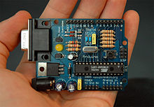](https://en.wikipedia.org/wiki/File:Arduino316.jpg)

An early Arduino board[[11]](https://en.wikipedia.org/wiki/Arduino#cite_note-11) with an [RS-232](https://en.wikipedia.org/wiki/RS-232) [serial](https://en.wikipedia.org/wiki/Serial_communication) interface (upper left) and an Atmel ATmega8 microcontroller chip (black, lower right); the 14 digital I/O pins are at the top, the 6 analog input pins at the lower right, and the power connector at the lower left.

An Arduino board consists of an [Atmel](https://en.wikipedia.org/wiki/Atmel) 8-, 16- or 32-bit AVR [microcontroller](https://en.wikipedia.org/wiki/Microcontroller) (although since 2015 other makers' microcontrollers have been used) with complementary components that facilitate programming and incorporation into other circuits. An important aspect of the Arduino is its standard connectors, which let users connect the CPU board to a variety of interchangeable add-on modules termed *shields*. Some shields communicate with the Arduino board directly over various pins, but many shields are individually addressable via an [I²C](https://en.wikipedia.org/wiki/I%C2%B2C)[serial bus](https://en.wikipedia.org/wiki/Serial_bus)—so many shields can be stacked and used in parallel. Before 2015, Official Arduinos had used the Atmel [megaAVR](https://en.wikipedia.org/wiki/MegaAVR" \o "MegaAVR) series of chips, specifically the ATmega8, ATmega168, [ATmega328](https://en.wikipedia.org/wiki/ATmega328), ATmega1280, and ATmega2560. In 2015, units by other producers were added. A handful of other processors have also been used by Arduino compatible devices. Most boards include a 5 V [linear regulator](https://en.wikipedia.org/wiki/Linear_regulator) and a 16 MHz [crystal oscillator](https://en.wikipedia.org/wiki/Crystal_oscillator) (or [ceramic resonator](https://en.wikipedia.org/wiki/Ceramic_resonator) in some variants), although some designs such as the LilyPad run at 8 MHz and dispense with the onboard voltage regulator due to specific form-factor restrictions. An Arduino's microcontroller is also pre-programmed with a [boot loader](https://en.wikipedia.org/wiki/Boot_loader) that simplifies uploading of programs to the on-chip [flash memory](https://en.wikipedia.org/wiki/Flash_memory), compared with other devices that typically need an external [chip programmer](https://en.wikipedia.org/wiki/Programmer_(hardware)). This makes using an Arduino more straightforward by allowing the use of an ordinary computer as the programmer. Currently, optiboot bootloader is the default bootloader installed on Arduino UNO.[[12]](https://en.wikipedia.org/wiki/Arduino#cite_note-12)

At a conceptual level, when using the Arduino integrated development environment, all boards are programmed over a serial connection. Its implementation varies with the hardware version. Some serial Arduino boards contain a level shifter circuit to convert between [RS-232](https://en.wikipedia.org/wiki/RS-232) logic levels and [transistor–transistor logic](https://en.wikipedia.org/wiki/Transistor%E2%80%93transistor_logic) (TTL) level signals. Current Arduino boards are programmed via [Universal Serial Bus](https://en.wikipedia.org/wiki/Universal_Serial_Bus) (USB), implemented using USB-to-serial adapter chips such as the [FTDI](https://en.wikipedia.org/wiki/FTDI) FT232. Some boards, such as later-model Uno boards, substitute the FTDI chip with a separate AVR chip containing USB-to-serial firmware, which is reprogrammable via its own ICSP header. Other variants, such as the Arduino Mini and the unofficial Boarduino, use a detachable USB-to-serial adapter board or cable, [Bluetooth](https://en.wikipedia.org/wiki/Bluetooth) or other methods, when used with traditional microcontroller tools instead of the Arduino IDE, standard AVR [in-system programming](https://en.wikipedia.org/wiki/In-system_programming) (ISP) programming is used.

[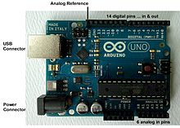](https://en.wikipedia.org/wiki/File:UnoConnections.jpg)

An official Arduino Uno R2 with descriptions of the I/O locations

The Arduino board exposes most of the microcontroller's I/O pins for use by other circuits. The *Diecimila*,[[a]](https://en.wikipedia.org/wiki/Arduino#cite_note-N10000-13) *Duemilanove*,[[b]](https://en.wikipedia.org/wiki/Arduino#cite_note-N2009-14) and current *Uno*[[c]](https://en.wikipedia.org/wiki/Arduino#cite_note-N1-15) provide 14 digital I/O pins, six of which can produce [pulse-width modulated](https://en.wikipedia.org/wiki/Pulse-width_modulation) signals, and six analog inputs, which can also be used as six digital I/O pins. These pins are on the top of the board, via female 0.1-inch (2.54 mm) headers. Several plug-in application shields are also commercially available. The Arduino Nano, and Arduino-compatible Bare Bones Board[[13]](https://en.wikipedia.org/wiki/Arduino#cite_note-16) and Boarduino[[14]](https://en.wikipedia.org/wiki/Arduino" \l "cite_note-17) boards may provide male header pins on the underside of the board that can plug into solderless [breadboards](https://en.wikipedia.org/wiki/Breadboard).

Many Arduino-compatible and Arduino-derived boards exist. Some are functionally equivalent to an Arduino and can be used interchangeably. Many enhance the basic Arduino by adding output drivers, often for use in school-level education, to simplify making buggies and small robots. Others are electrically equivalent but change the form factor, sometimes retaining compatibility with shields, sometimes not. Some variants use different processors, of varying compatibility.

## Digital Pins

The pins on the Arduino can be configured as either inputs or outputs. This document explains the functioning of the pins in those modes. While the title of this document refers to digital pins, it is important to note that vast majority of Arduino (Atmega) analog pins, may be configured, and used, in exactly the same manner as digital pins.

### Properties of Pins Configured as INPUT

Arduino (Atmega) pins default to inputs, so they don't need to be explicitly declared as inputs with pinMode() when you're using them as inputs. Pins configured this way are said to be in a **high-impedance state**. Input pins make extremely small demands on the circuit that they are sampling, equivalent to a series resistor of 100 megohm in front of the pin. This means that it takes very little current to move the input pin from one state to another, and can make the pins useful for such tasks as implementing [a capacitive touch sensor](http://www.arduino.cc/playground/Code/CapacitiveSensor), reading an LED as a [photodiode](http://www.arduino.cc/playground/Learning/LEDSensor), or reading an analog sensor with a scheme such as [RCTime.](https://www.arduino.cc/en/Tutorial/RCtime)

This also means however, that pins configured as pinMode(pin, INPUT) with nothing connected to them, or with wires connected to them that are not connected to other circuits, will report seemingly random changes in pin state, picking up electrical noise from the environment, or capacitively coupling the state of a nearby pin.

### Pullup Resistors with pins configured as INPUT

Often it is useful to steer an input pin to a known state if no input is present. This can be done by adding a pullup resistor (to +5V), or a pulldown resistor (resistor to ground) on the input. A 10K resistor is a good value for a pullup or pulldown resistor.

### Properties of Pins Configured as INPUT\_PULLUP

There are 20K pullup resistors built into the Atmega chip that can be accessed from software. These built-in pullup resistors are accessed by setting the pinMode() as INPUT\_PULLUP. This effectively inverts the behavior of the INPUT mode, where HIGH means the sensor is off, and LOW means the sensor is on.

The value of this pullup depends on the microcontroller used. On most AVR-based boards, the value is guaranteed to be between 20kΩ and 50kΩ. On the Arduino Due, it is between 50kΩ and 150kΩ. For the exact value, consult the datasheet of the microcontroller on your board.

When connecting a sensor to a pin configured with INPUT\_PULLUP, the other end should be connected to ground. In the case of a simple switch, this causes the pin to read HIGH when the switch is open, and LOW when the switch is pressed.

The pullup resistors provide enough current to dimly light an LED connected to a pin that has been configured as an input. If LEDs in a project seem to be working, but very dimly, this is likely what is going on.

The pullup resistors are controlled by the same registers (internal chip memory locations) that control whether a pin is HIGH or LOW. Consequently, a pin that is configured to have pullup resistors turned on when the pin is an INPUT, will have the pin configured as HIGH if the pin is then switched to an OUTPUT with pinMode(). This works in the other direction as well, and an output pin that is left in a HIGH state will have the pullup resistors set if switched to an input with pinMode().

### Properties of Pins Configured as OUTPUT

Pins configured as OUTPUT with pinMode() are said to be in a low-impedance state. This means that they can provide a substantial amount of current to other circuits. Atmega pins can source (provide positive current) or sink (provide negative current) up to 40 mA (milliamps) of current to other devices/circuits. This is enough current to brightly light up an LED (don't forget the series resistor), or run many sensors, for example, but not enough current to run most relays, solenoids, or motors.

Short circuits on Arduino pins, or attempting to run high current devices from them, can damage or destroy the output transistors in the pin, or damage the entire Atmega chip. Often this will result in a "dead" pin in the microcontroller but the remaining chip will still function adequately. For this reason it is a good idea to connect OUTPUT pins to other devices with 470Ω or 1k resistors, unless maximum current draw from the pins is required for a particular.

Technical specifications

|  |  |
| --- | --- |
| Microcontroller | [ATmega328P](http://www.atmel.com/Images/Atmel-42735-8-bit-AVR-Microcontroller-ATmega328-328P_Datasheet.pdf) |
| Operating Voltage | 5V |
| Input Voltage (recommended) | 7-12V |
| Input Voltage (limit) | 6-20V |
| Digital I/O Pins | 14 (of which 6 provide PWM output) |
| PWM Digital I/O Pins | 6 |
| Analog Input Pins | 6 |
| DC Current per I/O Pin | 20 mA |
| DC Current for 3.3V Pin | 50 mA |
| Flash Memory | 32 KB (ATmega328P) of which 0.5 KB used by bootloader |
| SRAM | 2 KB (ATmega328P) |
| EEPROM | 1 KB (ATmega328P) |
| Clock Speed | 16 MHz |
| LED\_BUILTIN | 13 |
| Length | 68.6 mm |
| Width | 53.4 mm |
| Weight | 25 g |
|  |  |

**ATmega328p Microcontroller**

# Introduction

The Atmel® picoPower® ATmega328/P is a low-power CMOS 8-bit microcontroller based on the AVR® enhanced RISC architecture. By executing powerful instructions in a single clock cycle, the ATmega328/P achieves throughputs close to 1MIPS per MHz. This empowers system designer to optimize the device for power consumption versus processing speed.

# Features

High Performance, Low Power Atmel®AVR® 8-Bit Microcontroller Family

Advanced RISC Architecture

* 131 Powerful Instructions
* Most Single Clock Cycle Execution
* 32 x 8 General Purpose Working Registers
* Fully Static Operation
* Up to 20 MIPS Throughput at 20MHz
* On-chip 2-cycle Multiplier

High Endurance Non-volatile Memory Segments

* 32KBytes of In-System Self-Programmable Flash program

**Memory**

* 1KBytes EEPROM
* 2KBytes Internal SRAM
* Write/Erase Cycles: 10,000 Flash/100,000 EEPROM
* Data Retention: 20 years at 85°C/100 years at 25°C(1)
* Optional Boot Code Section with Independent Lock Bits
* In-System Programming by On-chip Boot Program
* True Read-While-Write Operation

– Programming Lock for Software Security

* Atmel® QTouch® Library Support
  + Capacitive Touch Buttons, Sliders and Wheels
  + QTouch and QMatrix® Acquisition
  + Up to 64 sense channels
* Peripheral Features
  + Two 8-bit Timer/Counters with Separate Prescaler and Compare Mode
  + One 16-bit Timer/Counter with Separate Prescaler, Compare Mode, and Capture Mode
  + Real Time Counter with Separate Oscillator
  + Six PWM Channels
  + 8-channel 10-bit ADC in TQFP and QFN/MLF package
* Temperature Measurement
* 6-channel 10-bit ADC in PDIP Package

• Temperature Measurement

* Two Master/Slave SPI Serial Interface
* One Programmable Serial USART
* One Byte-oriented 2-wire Serial Interface (Philips I2C compatible)
* Programmable Watchdog Timer with Separate On-chip Oscillator
* One On-chip Analog Comparator
* Interrupt and Wake-up on Pin Change
* Special Microcontroller Features
  + Power-on Reset and Programmable Brown-out Detection
  + Internal Calibrated Oscillator
  + External and Internal Interrupt Sources
  + Six Sleep Modes: Idle, ADC Noise Reduction, Power-save, Power-down, Standby, and Extended Standby
* I/O and Packages
  + 23 Programmable I/O Lines
  + 28-pin PDIP, 32-lead TQFP, 28-pad QFN/MLF and 32-pad QFN/MLF
* Operating Voltage:
  + 1.8 - 5.5V
* Temperature Range:
  + -40°C to 105°C
* Speed Grade:
  + 0 - 4MHz @ 1.8 - 5.5V
  + 0 - 10MHz @ 2.7 - 5.5V
  + 0 - 20MHz @ 4.5 - 5.5V
* Power Consumption at 1MHz, 1.8V, 25°C
  + Active Mode: 0.2mA
  + Power-down Mode: 0.1μA
  + Power-save Mode: 0.75μA (Including 32kHz RTC)

**IR SENSOR:**

**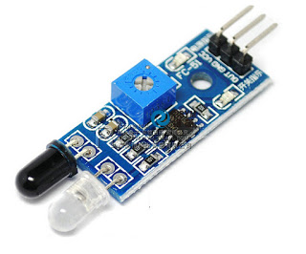**

**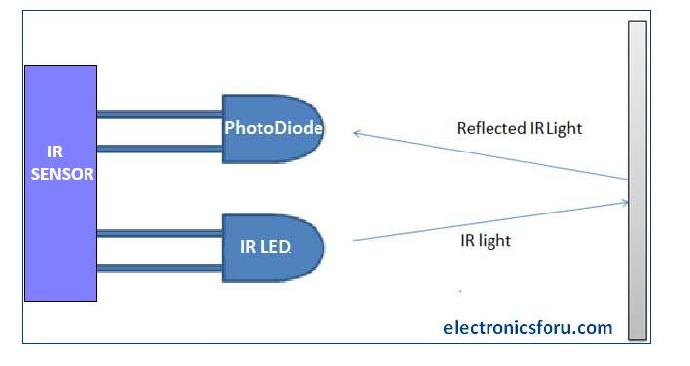**

**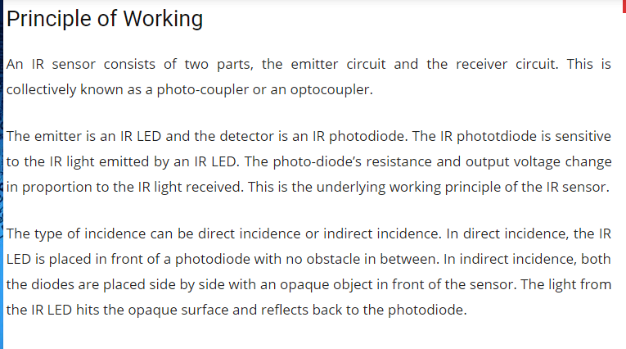**

**Advantages**

* Speed
* Lack of Interference
* Ability to measure in high temperature
  + Up to 3000 ° C
* Long lasting measurement, no mechanical wear
* Optimization of manufacturing processes
* Fever inspection of patients or travelers
* Line scanning in glass toughening lines
* Checking mechanical or electrical equipment for temperature and hot spots
* Checking heater or oven temperature, for calibration and control
* Checking for hot spots in fire-fighting
* Food Processing

**Gas Sensor:**

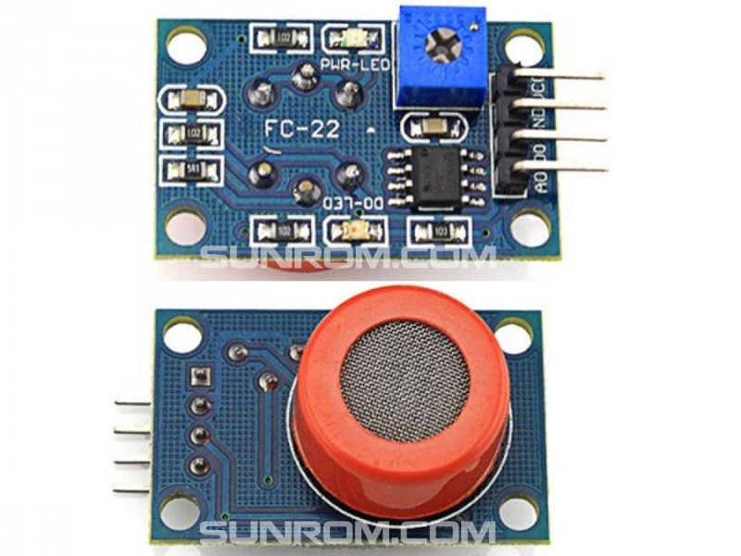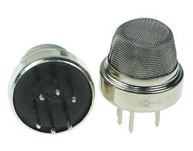

* This module is made using Alcohol Gas Sensor MQ3. It is a low cost semiconductor sensor which can detect the presence of alcohol gases at concentrations from 0.05 mg/L to 10 mg/L. The sensitive material used for this sensor is SnO2, whose conductivity is lower in clean air. It’s conductivity increases as the concentration of alcohol gases increases. It has high sensitivity to alcohol and has a good resistance to disturbances due to smoke, vapor and gasoline. This module provides both digital and analog outputs.
* MQ3 alcohol sensor module can be easily interfaced with Microcontrollers, Arduino Boards, Raspberry Pi etc.
* This alcohol sensor is suitable for detecting alcohol concentration on your breath, just like your common breathalyzer. It has a high sensitivity and fast response time. Sensor provides an analog resistive output based on alcohol concentration.
* The drive circuit is very simple, all it needs is one resistor. A simple interface could be a 0-3.3V ADC.

**Features**

* 5V operation,Simple to use
* LEDs for output and power,Output sensitivity adjustable
* Analog output 0V to 5V & Digital output 0V or 5V Low Cost
* Fast Response
* Stable and Long Life
* Good Sensitivity to Alcohol Gas
* Both Digital and Analog Outputs
* On-board LED Indicator

**Technical Data**

* Concentration : 0.05 mg/L ~ 10 mg/L Alcohol
* Operating Voltage : 5V ±0.1
* Current Consumption : 150mA
* Operation Temperature : -10°C ~ 70°C

**Pin Out**

* VCC – Input Power Supply
* GND – Supply Ground
* DO – Digital Output
* AO – Analog Output

**Applications**

* Vehicle Alcohol Detector
* Portable Alcohol Detector

**Pressure Sensor:**

**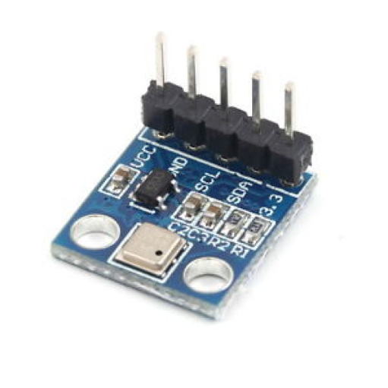**

**Working:**

A pressure sensor is a device which senses pressure and converts it into an analog electric signal whose magnitude depends upon the pressure applied. Since they convert pressure into an electrical signal, they are also termed as pressure transducers.

Pressure transducers have a sensing element of constant area and respond to force applied to this area by fluid pressure. The force applied will deflect the diaphragm inside the pressure transducer. The deflection of the internal diaphragm is measured and converted into an electrical output. This allows the pressure to be monitored by microprocessors, programmable controllers and computers along with similar electronic instruments. Most Pressure transducers are designed to produce linear output with applied pressure.

**Types of Pressure Measurements**

Pressure measurement can either be relative to a reference value or on an absolute scale.

**1.   Absolute Pressure Measurement:** Pressure measured relative to perfect vacuum is termed

as absolute pressure. Perfect vacuum is a condition where there is no matter present in the atmosphere and hence, nil air pressure exists in that region. Absolute pressure sensors have limited usage because it is impossible to attain a state of perfect vacuum. Hence, sensors based on absolute pressure measurement require strict specifications for precise outputs. Sensors based on this type of measurement are used in barometric or altitude related pressure measurements.

**2.   Differential Pressure Measurement:**  In differential pressure measurement, pressures of two distinct positions are compared.  For example, pressure difference calculated by measuring it at different floors of a tall building will give us differential pressure. Differential pressure measurements, typically taken in pound per square inch differential (psid), are applied when high amount of pressure is to be measured. These types of measurements are used for feed pressure monitoring purposes where the pressure with which the fluid is flowing in a medium is monitored, so that homogeneity in the flow can be maintained.

Differential pressure measurements find an important application in monitoring filters in various types of purification systems. They take the reference of the normal pressure with which the filters clean the fluid. Whenever the filters face the problem of clogging due to contaminants, these pressure sensors give a reading relative to the normal pressure. This helps in keeping the filter clean and operational.

**3.   Gauge Pressure Measurement:** It can be defined as a subtype of differential pressure measurement where we compare pressure at any point to the current atmospheric pressure. Gauge pressure measurement is used in applications like tire pressure or blood pressure measurement. There is no consistency in gauge pressure measurements because atmospheric pressure does vary with altitude and hence its applications are limited to non-critical measurements.

**Accelerometer Sensor:**

**What is an accelerometer?**

An accelerometer is an electromechanical device that will measure acceleration forces. These forces may be static, like the constant force of gravity pulling at your feet, or they could be dynamic - caused by moving or vibrating the accelerometer.

**What are accelerometers useful for?**

By measuring the amount of static acceleration due to gravity, you can find out the angle the device is tilted at with respect to the earth. By sensing the amount of dynamic acceleration, you can analyze the way the device is moving. At first, measuring tilt and acceleration doesn't seem all that exciting. However, engineers have come up with many ways to make really useful products with them.  
  
An accelerometer can help your project understand its surroundings better. Is it driving uphill? Is it going to fall over when it takes another step? Is it flying horizontally or is it dive bombing your professor? A good programmer can write code to answer all of these questions using the data provided by an accelerometer. An accelerometer can help analyze problems in a car engine using vibration testing, or you could even use one to make a [musical instrument](http://www.hpl.hp.com/techreports/2005/HPL-2005-81.pdf).  
  
In the computing world, IBM and Apple have recently started using accelerometers in their laptops to protect hard drives from damage. If you accidentally drop the laptop, the accelerometer detects the sudden freefall, and switches the hard drive off so the heads don't crash on the platters. In a similar fashion, high g accelerometers are the industry standard way of detecting car crashes and deploying airbags at just the right time.

#### **Working**

The most commonly used device is the piezoelectric accelerometer. As the name suggests, it uses the principle of [**piezoelectric effect**](http://www.instrumentationtoday.com/piezoelectric-transducer/2011/07/). The device consists of a piezoelectric quartz crystal on which an accelerative force, whose value is to be measured, is applied.Due to the special self-generating property, the crystal produces a voltage that is proportional to the accelerative force.

As the device finds its application as a highly accurate vibration measuring device, it is also called a vibrating sensor. Vibration sensors are used for the measurement of vibration in bearings of heavy equipment and pressure lines. The piezoelectric accelerometer can be classified into two. They are high impedance output accelerometer and low impedance accelerometer.

In the case of high impedance device, the output voltage generated in proportion to the acceleration is given as the input to other measuring instruments. The instrumentation process and signal conditioning of the output is considered high and thus a low impedance device cannot be of any use for this application. This device is used at temperatures greater than 120 degree Celsius.

The low impedance accelerometer produces a current due to the output voltage generated and this charge is given to a FET transistor so as to convert the charge into a low impedance output. This type of accelerometers is most commonly used in industrial applications.

**GAS(Alcohol sensor):**

****

* This module is made using Alcohol Gas Sensor MQ3.
* It is a low cost semiconductor sensor which can detect the presence of alcohol gases at concentrations from 0.05 mg/L to 10 mg/L.
* The sensitive material used for this sensor is SnO2, whose conductivity is lower in clean air. It’s conductivity increases as the concentration of alcohol gases increases.
* It has high sensitivity to alcohol and has a good resistance to disturbances due to smoke, vapor and gasoline. This module provides both digital and analog outputs.
* MQ3 alcohol sensor module can be easily interfaced with Microcontrollers, Arduino Boards, Raspberry Pi etc.
* This alcohol sensor is suitable for detecting alcohol concentration on your breath, just like your common breathalyzer.
* It has a high sensitivity and fast response time. Sensor provides an analog resistive output based on alcohol concentration.
* The drive circuit is very simple, all it needs is one resistor. A simple interface could be a 0-3.3V ADC.

**Features**

* 5V operation, Simple to use
* LEDs for output and power, Output sensitivity adjustable
* Analog output 0V to 5V & Digital output 0V or 5V Low Cost
* Fast Response
* Stable and Long Life
* Good Sensitivity to Alcohol Gas
* Both Digital and Analog Outputs
* On-board LED Indicator

**Technical Data**

* Concentration : 0.05 mg/L ~ 10 mg/L Alcohol
* Operating Voltage : 5V ±0.1
* Current Consumption : 150mA
* Operation Temperature : -10°C ~ 70°C

**Pin Out**

* VCC – Input Power Supply
* GND – Supply Ground
* DO – Digital Output
* AO – Analog Output

**Applications**

* Vehicle Alcohol Detector
* Portable Alcohol Detector

**Interfacing Gas sensor to arduino**

**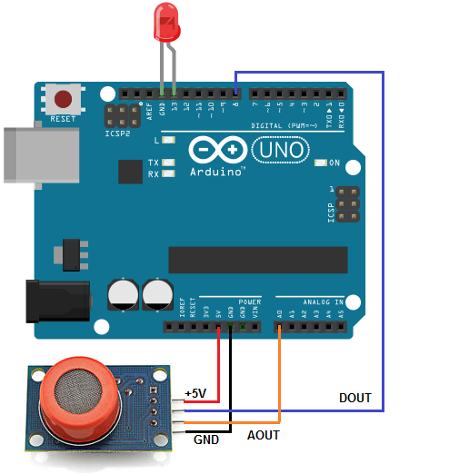**

**GPS**

Using the Global Positioning System (GPS, all process used to establish all position at any point on the globe) the following two values can be determined anywhere on Earth. GPS receivers are used for positioning, locating, navigating, surveying and determining the time and are employed both by private individuals(e.g. for leisure activities, such as trekking, balloon flights and cross-country skiing etc) and companies (surveying, determining the time, navigation, vehicle monitoring etc)

GPS (the full description is: NAVigation System with Timing And Ranging Global Positioning System, NAVSTAR-GPS) was developed by the U.S. Department of Defense (DoD) and can be used both by civilians and military personnel. The civil signal SPS (standard positioning service) can be used freely by the general public, whilst the military signal PPS (Precise positioning service) can only be used by authorized government agencies. The first satellite was placed in orbit on 22nd February 1978, and there are currently 28 operational satellites orbiting the earth at a height of 20,180km on 6 different orbital planes. Their orbits are inclined at 55degree to the equator, ensuring that at least 4 satellites are in radio communication with any point on the planet. Each satellite orbits the earth in approximately 12 hours and has four atomic clocks on board.

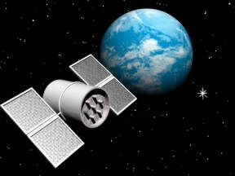

**Segments:**

GPS uses radio transmissions. The satellites transmit timing information and satellite location information . the system can be separated into three parts:

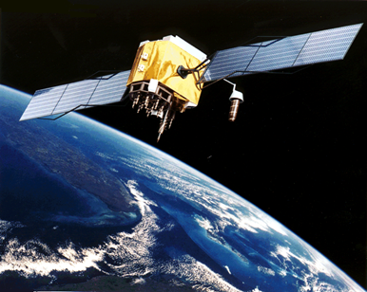

Space segment

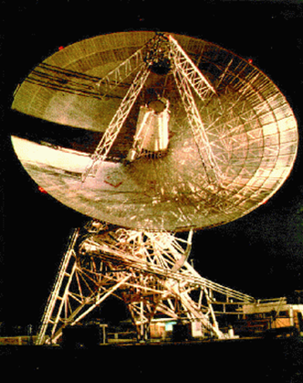

Control segment

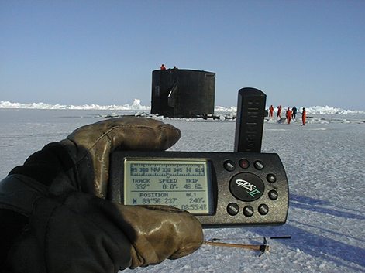

User segment

**Space segment**

* The space segment consists of the satellites themselves.
* According to the United state Naval observatory there are currently 27 operational GPS satellites about 11,000 miles up in space.
* This constellation provides between five and eight GPS satellites visible from any point on the earth.

**Control segment**

* The control segment is a group of ground stations that monitor and operate the GPS satellites. There are monitoring stations spaced around the globe and one Master Control Station located in Colorado Springs

**User segment**

* The user requires a GPS receiver in order to receive the transmissions from the satellites. The GPS receiver calculates the location based on signals from the satellites
* The users consist of both the military and civilians.

**Applications of GPS**

* Car navigation
* Dynamic vehicle routing
* Tracking rental cars
* Monitoring high risk auto loans
* **TILT SENOSR**
* The Paris Air show is one of the biggest platforms for various airplane manufacturers to showcase the swiftness of their planes. Some of the valiant pilots of the world perform amazing stunts. These pilots are supported by the power of fast computing machinery in their airplanes. One of the critical parts of this computer assisted circuitry is the tilt sensor. A type of transducer, **tilt sensor** aids in giving information about the vertical as well as horizontal inclination of the airplane so that the pilot can understand how can he tackle the obstacles during the flight and perform the stunts.
* 
* Keeping the pilots informed about the current orientation of the plane, the angle at which they are inclined to earth’s surface, tilt sensors play a very important role in decision making for the pilots. These types of transducer produce an electric signal proportional to the degree of inclination with respect one or multiple axes. This article will detail more **about tilt sensor**, the **types of tilt sensors**, need and their **applications**. Let’s dig in deep to **know about tilt sensors**.
* **Need and Applications of Tilt Sensor.**
* Tilt sensors play a vital role in numerous applications. Diversely popular in multiple fields, tilt sensors are needed in:
* Off Road Vehicles: Off road vehicles such tractors, rock crawling jeeps or tanks are subjected to diverse types of surface terrains. From gravels to sands or marshy areas, these vehicles are expected to perform on every surface. The irregularity and unpredictability of such surfaces is a potential accidental hazard to the vehicle. In the cases when these vehicles are carrying heavy loads, they can tip over or roll down on sudden bumps. Hence, to assist the driver in keeping the vehicle tuned with the surface, tilt sensors play a vital role. In any cases of vertical or horizontal movement of the vehicle, the tilt sensors keep the driver updated so that he knows at which speed he should drive or how he should put the load on the vehicle for safe driving.
* **· Portable Computers:** A popular advertisement about a portable computer says “There is no wrong way or right way you hold the device”. This phrase means that the display of that computer aligns itself in the manner user is holding it and he can tiltit the way he wants. Tilt sensors are required to keep the device display in the correct position with the way user holds it. Often, motion based gaming devices use this application of tilt sensor or tilt sensor derived accelerometer.
* **· Vehicular Security Systems:** Several vehicle security alarm systems are based on tilt sensors. In the cases of unauthorized vehicle towing or movement of steering, tilt sensor engages the alarm. This in turn produces an electric signal and the alarm starts sounding.
* **· Aviation:** In airplanes and helicopters, tilt sensors, along with inclinometers form an altitude monitoring system through which the pilot can monitor the inclinations of the flying machine.
* **· Robotics:** For any type of robot, balance is one of the most important criteria to be taken care of. Whenever a robot inclines to any direction, tilt sensor aids in giving details about corresponding incline in form of electrical signals. It thus makes the robot judge on its own that whether it is supposed to get aligned or not.
* **GSM/GPRS Module**
* A GSM/GPRS module assembles a GSM/GPRS modem with standard communication interfaces like RS-232 (Serial Port), USB etc., so that it can be easily interfaced with a computer or a microprocessor / microcontroller based system. The power supply circuit is also built in the module that can be activated by using a suitable adaptor.
* GSM/GPRS Module, Modem
* 
* **Mobile Station (Cell phones and SIM)**
* A mobile phone and Subscriber Identity Module (SIM) together form a mobile station. It is the user equipment that communicates with the mobile network. A mobile phone comprises of Mobile Termination, Terminal Equipment and Terminal Adapter.
* 
* How GSM/GPRS Works
* **Mobile Termination** is interfaced with the GSM mobile network and is controlled by a baseband processor. It handles access to SIM, speech encoding and decoding, signaling and other network related tasks. The **Terminal Equipment** is an application processor that deals with handling operations related to keypad, screen, phone memory and other hardware and software services embedded into the handset. The **Terminal Adapter** establishes communication between the Terminal Equipment and the Mobile Termination using AT commands. The communication with the network in a GSM/GPRS mobile is carried out by the baseband processor.
* **Difference between GSM mobile and GSM/GPRS module**
* A GSM mobile is a complete system in itself with embedded processors that are dedicated to provide an interface between the user and the mobile network. The AT commands are served between the processors of the mobile termination and the terminal equipment. The mobile handset can also be equipped with a USB interface to connect with a computer, but it may or may not support AT commands from the computer or an external processor/controller.
* The GSM/GPRS module, on the other hand, always needs a computer or external processor/controller to receive AT commands from. GSM/GPRS module itself does not provide
* any interface between the user and the network, but the computer to which module is connected is the interface between user and network.
* An advantage that GSM/GPRS modules offer is that they support concatenated SMS which may not be supported in some GSM mobile handsets. Also some mobile handsets can’t receive MMS when connected to a computer.
* **Applications of GSM/GPRS module**
* The GSM/GPRS module demonstrates the use of AT commands. They can feature all the functionalities of a mobile phone through computer like making and receiving calls, SMS, MMS etc. These are mainly employed for computer based SMS and MMS services.
* **AT Commands**
* AT commands are used to control MODEMs. AT is the abbreviation for Attention. These commands come from Hayes commands that were used by the Hayes smart modems. The Hayes commands started with AT to indicate the attention from the MODEM. The dial up and wireless MODEMs (devices that involve machine to machine communication) need AT commands to interact with a computer. These include the Hayes command set as a subset, along with other extended AT commands.
* AT commands with a GSM/GPRS MODEM or mobile phone can be used to access following information and services:
* 1. Information and configuration pertaining to mobile device or MODEM and SIM card.
* 2. SMS services.
* 3. MMS services.
* 4. Fax services.
* 5. Data and Voice link over mobile network.
* The Hayes subset commands are called the basic commands and the commands specific to a GSM network are called extended AT commands.
* **Command, Information response and Result Codes:**
* The AT commands are sent by the computer to the MODEM/ mobile phone. The MODEM sends back an Information Response i.e. the information requested by or pertaining to the action initiated by the AT command. This is followed by a Result Code. The result code tells about the successful execution of that command.
* 
* Execution of AT Commands
* There are also unsolicited Result Codes that are returned automatically by the MODEM to notify the occurrence of an event. For example the reception of a SMS will force MODEM to return an unsolicited result code.
* **AT commands' syntax**
* **Case Sensitivity -**
* The AT commands are generally used in uppercase letters. However some MODEMs and mobile phones allow both uppercase and small case letters.
* **Single Command -**
* The AT commands include a **prefix AT** which indicates the beginning of the command to MODEM; and a **carriage return** which indicates the end of the command.
* 
* Using a Single AT Command
* However string ‘AT’ itself is not the part of the command. For example in ATD, D is the command name not ATD.
* The extended AT commands have a ‘+’ in the command name.
* For example: **AT+CGMI<Carriage return>**
* **Command Line -**
* Multiple AT commands can be sent to MODEM in a single command line. The commands in a line are separated by a semi-colon (;).
* 
* For example: **AT+CGMI; +CBS<Carriage return>**
* **String in Command Line -**
* Strings in a command line are enclosed in double quotes.
* For example: **AT+CGML=”ALL”<Carriage return>**
* **Information Response and Result Code –**
* The Information Response and Result Codes, returned by the MODEM, have a carriage return and line feed in the beginning as well as at the end.
* 
* Information Response and Result Code
* For example:
* **<Carriage return><Line feed>OK<Carriage return><Line feed>**
* **<Carriage return><Line feed>ERROR<Carriage return><Line feed>**
* **<Carriage return><Line feed>+CBC: 0, 60<Carriage return><Line feed> etc.**
* **Sequence of Execution -**
* In the command line, the command appearing first is executed first. The execution then follows for second appeared command and so on. The execution of commands in a command line takes place in sequential manner.
* If an error occurs in the execution of a command, an error result code is returned by the MODEM and the execution of the command line is terminated irrespective of presence of other commands next in the command line.
* **Types of commands:**
* There are four types of AT commands:
* 1) Test commands
* 2) Read commands
* 3) Set commands
* 4) Execution commands
* **Interfacing MODEM/Mobile phone with Windows platform**
* The Windows (XP and lower versions) comes with an application called **HyperTerminal** for data communication through serial port of the computer. The interfacing of the GSM/GPRS module with the serial port of the computer involves following steps:
* 1) Connect RS-232 port of GSM module with the serial port of the computer. Insert a SIM card in the module.
* 2) Open HyperTerminal from Start -> All Programs -> Accessories -> Communications -> HyperTerminal.
* 3) Enter a name for the connection and press OK.
* 4) Now select the communication port (COM) at which GSM module is connected.
* 5) Create a new connection set on HyperTerminal. Set parameters, like baud rate as 9600, handshaking mode as none, parity bit as none, stop bit as 1 and data bit as 8.
* VIBRATION SENSOR
* Here a simple Vibration sensor to protect door or window. It generates a loud beep when somebody tries to break the door or window. The alarm stops automatically after three minutes. The circuit uses a piezo element as the vibration sensor.
* Piezo buzzer exploits the piezoelectric property of the piezo electric crystals. The piezoelectric effect may be direct piezoelectric effect in which the electric charge develops as a result of the mechanical stressor reverse or indirect piezoelectric effect (Converse piezoelectric effect) in which a mechanical force such as vibration develops due to the application of an electric field.
* 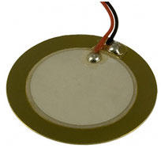
* A typical example of direct piezoelectric effect is the generation of measurable amount of piezoelectricity when the Lead Zirconate Titanate crystals are deformed by mechanical or heat stress. The Lead Zirconate Titanate crystals also shows indirect piezoelectric effect by showing vibration when an electric potential is applied. This is the principle of sound generation in Piezo buzzer, Piezoelectric mic etc.
* 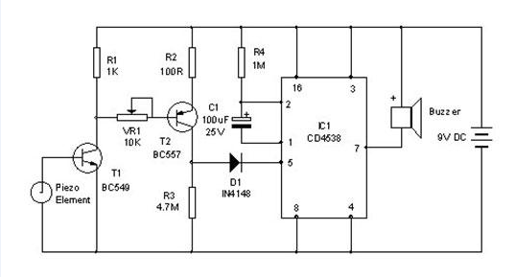
* Here the direct piezoelectric effect is used to trigger the circuit. The piezo element is connected to the base of transistor T1 (The white piezo material in the centre of the element is positive while the metal rim is negative). When the piezo element vibrates, it generates around 1-2 volts that forward biases T1 followed by the triggering of T2. When T2 conducts, a short pulse will be given to the trigger pin 5 of IC1 through diode D1.
* CD4538 (IC1) is the precision monostable multivibrator free from false triggering and more reliable than [IC 555](http://www.engineersgarage.com/electronic-components/ne555-timer-ic-datasheet). Unlike 555, it triggers when it get a positive pulse in the trigger input. Timing resistor is connected between the positive rail and pin 2 and thetiming capacitor between the pins 2 and 1. Unlike 555, the output of CD 4538 remains high at power on and turns low when triggered by a low-to-hightransition pulse. Once triggered, it gives a low output depending on the values of timing resistor and timing capacitor. Here it is around 3 minutes.
* Use 9 -12 volts DC for the circuit. Fix the piezo element on the door or window by applying glue on the smooth metal side. Connect the piezo element with the circuit using thin wire. Care should be taken while soldering the wire to the piezo element especially in the central part. The piezo material is coated as thin film in the central part. So first tin the tip of the wire and place the wire tip over the piezo material and gently apply solder once. Do not over heat or apply pressure to avoid peeling of the material. After soldering both the wires, paste a Cellotape over the soldering points so that, the wire will not detach.
* Adjust VR1 to set the sensitivity of the circuit.

**IOT**

IoT (Internet of Things) is an advanced automation and analytics system which exploits networking, sensing, big data, and artificial intelligence technology to deliver complete systems for a product or service. These systems allow greater transparency, control, and performance when applied to any industry or system.

IoT systems have applications across industries through their unique flexibility and ability to be suitable in any environment. They enhance data collection, automation, operations, and much more through smart devices and powerful enabling technology.

IoT systems allow users to achieve deeper automation, analysis, and integration within a system. They improve the reach of these areas and their accuracy. IoT utilizes existing and emerging technology for sensing, networking, and robotics.

IoT exploits recent advances in software, falling hardware prices, and modern attitudes towards technology. Its new and advanced elements bring major changes in the delivery of products, goods, and services; and the social, economic, and political impact of those changes.

**IOT FEATURES**

The most important features of IoT include artificial intelligence, connectivity, sensors, active engagement, and small device use. A brief review of these features is given below −

* **AI** − IoT essentially makes virtually anything “smart”, meaning it enhances every aspect of life with the power of data collection, artificial intelligence algorithms, and networks. This can mean something as simple as enhancing your refrigerator and cabinets to detect when milk and your favorite cereal run low, and to then place an order with your preferred grocer.
* **Connectivity** − New enabling technologies for networking, and specifically IoT networking, mean networks are no longer exclusively tied to major providers. Networks can exist on a much smaller and cheaper scale while still being practical. IoT creates these small networks between its system devices.
* **Sensors** − IoT loses its distinction without sensors. They act as defining instruments which transform IoT from a standard passive network of devices into an active system capable of real-world integration.
* **Active Engagement** − Much of today's interaction with connected technology happens through passive engagement. IoT introduces a new paradigm for active content, product, or service engagement.
* **Small Devices** − Devices, as predicted, have become smaller, cheaper, and more powerful over time. IoT exploits purpose-built small devices to deliver its precision, scalability, and versatility.

**IOT ADVANTAGES**

The advantages of IoT span across every area of lifestyle and business. Here is a list of some of the advantages that IoT has to offer −

* **Improved Customer Engagement** − Current analytics suffer from blind-spots and significant flaws in accuracy; and as noted, engagement remains passive. IoT completely transforms this to achieve richer and more effective engagement with audiences.
* **Technology Optimization** − The same technologies and data which improve the customer experience also improve device use, and aid in more potent improvements to technology. IoT unlocks a world of critical functional and field data.
* **Reduced Waste** − IoT makes areas of improvement clear. Current analytics give us superficial insight, but IoT provides real-world information leading to more effective management of resources.
* **Enhanced Data Collection** − Modern data collection suffers from its limitations and its design for passive use. IoT breaks it out of those spaces, and places it exactly where humans really want to go to analyze our world. It allows an accurate picture of everything.

**IOT SOFTWARE**

IoT software addresses its key areas of networking and action through platforms, embedded systems, partner systems, and middleware. These individual and master applications are responsible for data collection, device integration, real-time analytics, and application and process extension within the IoT network. They exploit integration with critical business systems (e.g., ordering systems, robotics, scheduling, and more) in the execution of related tasks.

## Data Collection

This software manages sensing, measurements, light data filtering, light data security, and aggregation of data. It uses certain protocols to aid sensors in connecting with real-time, machine-to-machine networks. Then it collects data from multiple devices and distributes it in accordance with settings. It also works in reverse by distributing data over devices. The system eventually transmits all collected data to a central server.

## Device Integration

Software supporting integration binds (dependent relationships) all system devices to create the body of the IoT system. It ensures the necessary cooperation and stable networking between devices. These applications are the defining software technology of the IoT network because without them, it is not an IoT system. They manage the various applications, protocols, and limitations of each device to allow communication.

## Real-Time Analytics

These applications take data or input from various devices and convert it into viable actions or clear patterns for human analysis. They analyze information based on various settings and designs in order to perform automation-related tasks or provide the data required by industry.

## Application and Process Extension

These applications extend the reach of existing systems and software to allow a wider, more effective system. They integrate predefined devices for specific purposes such as allowing certain mobile devices or engineering instruments access. It supports improved productivity and more accurate data collection.

**IOT TECHNOLOGY AND PROTOCOLS**

IoT primarily exploits standard protocols and networking technologies. However, the major enabling technologies and protocols of IoT are RFID, NFC, low-energy Bluetooth, low-energy wireless, low-energy radio protocols, LTE-A, and WiFi-Direct. These technologies support the specific networking functionality needed in an IoT system in contrast to a standard uniform network of common systems.

## NFC and RFID

RFID (radio-frequency identification) and NFC (near-field communication) provide simple, lowenergy, and versatile options for identity and access tokens, connection bootstrapping, and payments.

* RFID technology employs 2-way radio transmitter-receivers to identify and track tags associated with objects.
* NFC consists of communication protocols for electronic devices, typically a mobile device and a standard device.

## Low-Energy Bluetooth

This technology supports the low-power, long-use need of IoT function while exploiting a standard technology with native support across systems.

## Low-Energy Wireless

This technology replaces the most power hungry aspect of an IoT system. Though sensors and other elements can power down over long periods, communication links (i.e., wireless) must remain in listening mode. Low-energy wireless not only reduces consumption, but also extends the life of the device through less use.

## Radio Protocols

ZigBee, Z-Wave, and Thread are radio protocols for creating low-rate private area networks. These technologies are low-power, but offer high throughput unlike many similar options. This increases the power of small local device networks without the typical costs.

## LTE-A

LTE-A, or LTE Advanced, delivers an important upgrade to LTE technology by increasing not only its coverage, but also reducing its latency and raising its throughput. It gives IoT a tremendous power through expanding its range, with its most significant applications being vehicle, UAV, and similar communication.

## WiFi-Direct

WiFi-Direct eliminates the need for an access point. It allows P2P (peer-to-peer) connections with the speed of WiFi, but with lower latency. WiFi-Direct eliminates an element of a network that often bogs it down, and it does not compromise on speed or throughput.

**BLYNK APP**

Blynk is a toolset for all makers, badass inventors, designers, teachers, nerds and geeks who would love to use their smartphones to control electronics like Arduino, RaspberryPi and similar ones. We’ve done all the hard work of establishing internet connection, building an app and writing hardware code.

With Blynk, you simply snap together an amazing interface from various widgets we provide, upload the example code to your hardware and enjoy seeing first results in under 5 minutes! It works perfectly for newbie makers and saves tons of time for evil geniuses.

Blynk will work with all popular boards and shields. We wanted to give you full freedom when deciding how to plug Blynk into your existing or new project. You will also enjoy the convenience of Blynk Cloud. Which is, by the way is free and open-source.

Imagine a prototyping board on your smartphone where you drag and drop buttons, sliders, displays, graphs and other functional widgets. And in a matter of minutes these widgets can control Arduino and get data from it.

Blynk is not an app that works only with a particular shield. Instead, it's been designed to support the boards and shields you are already using. And it works on iOs and Android.

**UPD:** Blynk also works over USB. This means you can tinker with the app by connecting it to your laptop or desktop while waiting for some internet shield to arrive.

**Blynk works over the Internet.**So the one and only requirement is that your hardware can talk to the Internet.

No matter what type of connection you choose - Ethernet, Wi-Fi or maybe this new ESP8266 everyone is talking about – Blynk libraries and example sketches will get you online, connect to Blynk Server and pair up with your smartphone.

**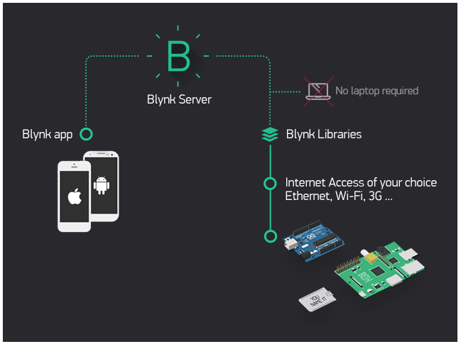**

**FIG:** Blynk architecture

Currently, Blynk libraries work with:

* USB
* Ethernet shield
* WiFi shield
* Arduino with Ethernet
* Arduino YÚN (testing in progress)
* ESP8266
* Raspberry Pi (Blynk will communicate with Pi's GPIOs)
* more Arduino compatible shields and boards (this list will be updated as we test the compatibility)

It's not that easy to take Arduino out of your home network, so we've built a Blynk server. It handles all the authentication and communication, and also keeps an eye on your board while the smartphone is offline. Blynk server runs on Java and is open-source. You will be able to run it locally if you really need to. Messaging between mobile apps , Blynk Server and Arduino is based on a simple, lightweight and fast binary protocol over TCP/IP sockets.

**CREATING A PROJECT IN BLYNK APP**

After downloading the app, create an account and log in. Welcome to Blynk!

[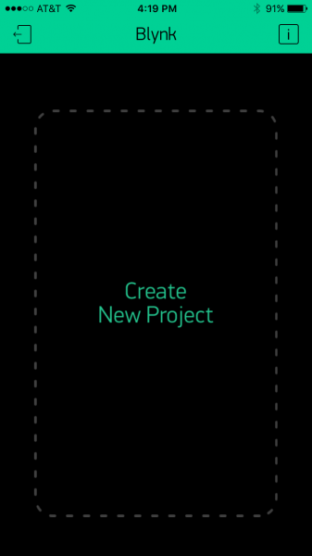](https://cdn.sparkfun.com/assets/learn_tutorials/4/4/5/blynk-blank.PNG)

You’ll also need to install the **Blynk Arduino Library**, which helps generate the firmware running on your ESP8266. Download the latest release from Blynk’s GitHub repo, and follow along with the directions there to install the required libraries.

### Create a Blynk Project

Next, click the “Create New Project” in the app to create a new Blynk app. Give it any name you please, just make sure the “Hardware Model” is set to **ESP8266**.

[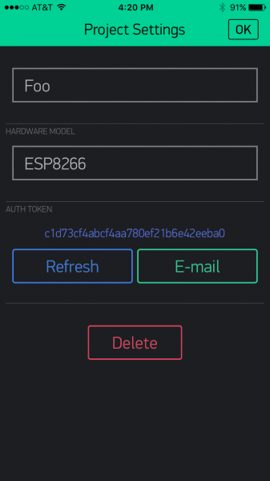](https://cdn.sparkfun.com/assets/learn_tutorials/4/4/5/Blynk-new.PNG)

The **Auth Token** is very important – you’ll need to stick it into your ESP8266’s firmware. For now, copy it down or use the “E-mail” button to send it to yourself.

### Add Widgets to the Project

Then you’ll be presented with a blank new project. To open the widget box, click in the project window to open.

[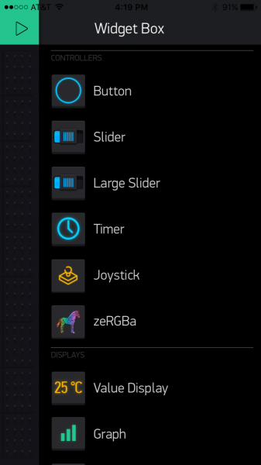](https://cdn.sparkfun.com/assets/learn_tutorials/4/4/5/Blynk-widgetBox.PNG)

Add a **Button**, then click on it to change its settings. Buttons can toggle outputs on the ESP8266. Set the button’s output to **gp5**, which is tied to an LED on the Thing Dev Board. You may also want to change the action to “Switch.”

[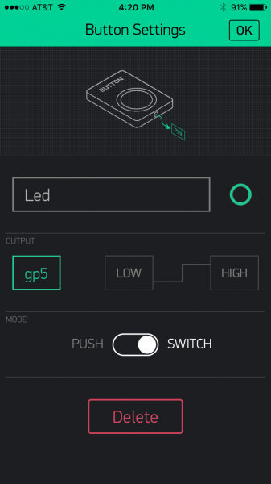](https://cdn.sparkfun.com/assets/learn_tutorials/4/4/5/Blynk-Button.PNG)

### Upload the Blynk Firmware

Now that your Blynk project is set up, open Arduino and navigate to the **ESP8266\_Standalone** example in the **File** > **Examples** > **Blynk** > **BoardsAndShields** menu.

[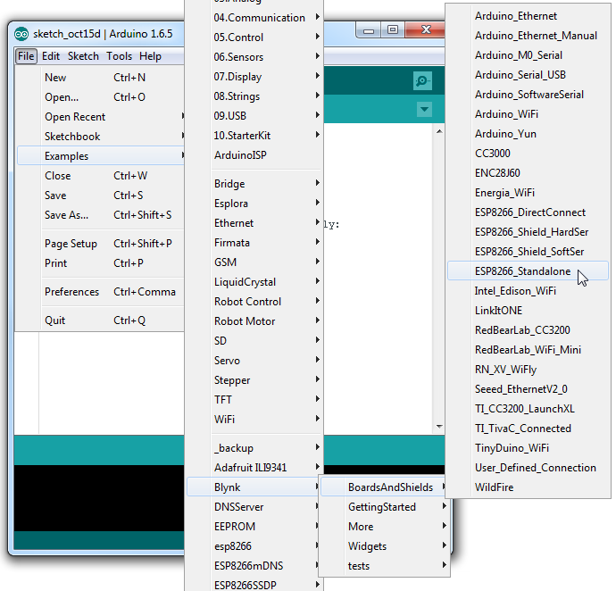](https://cdn.sparkfun.com/assets/learn_tutorials/4/4/5/Blynk-example.png)

Before uploading, make sure to paste your **authoriazation token** into the auth[] variable. Also make sure to **load your WiFi network settings into the Blynk.begin(auth, "ssid", "pass")** function.

Then upload!

### Run the Project

After the app has uploaded, open the serial monitor, setting the baud rate to 9600. Wait for the “Ready (ping: xms).” message.

[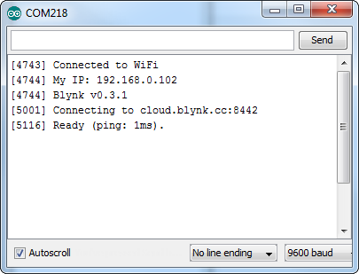](https://cdn.sparkfun.com/assets/learn_tutorials/4/4/5/Blynk-Serial.png)

Then click the “Run” button in the top right corner of the Blynk app. Press the button and watch the LED!

[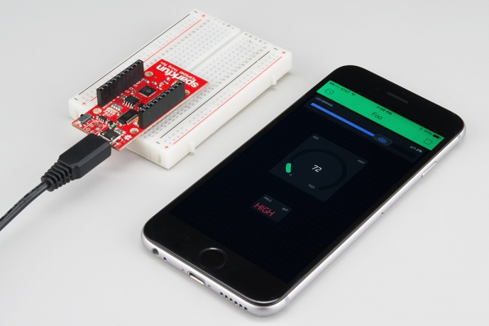](https://cdn.sparkfun.com/assets/learn_tutorials/4/4/5/esp8266-blynk.jpg)

Then add more widgets to the project. They should immediately work on the ESP8266 without uploading any new firmware.

[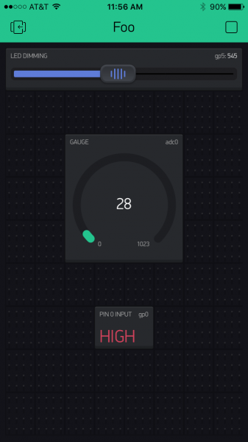](https://cdn.sparkfun.com/assets/learn_tutorials/4/4/5/Blynk-fullExample.PNG)

You can add analog output sliders, digital input monitors, and analog input gauges.

**CLOUD**

Cloud Computing provides us means of accessing the applications as utilities over the Internet. It allows us to create, configure, and customize the applications online.

**What is Cloud?**

The term **Cloud** refers to a **Network** or **Internet.** In other words, we can say that Cloud is something, which is present at remote location. Cloud can provide services over public and private networks, i.e., WAN, LAN or VPN.

Applications such as e-mail, web conferencing, customer relationship management (CRM) execute on cloud.

**What is Cloud Computing?**

Cloud Computing refers to **manipulating, configuring,** and **accessing** the hardware and software resources remotely. It offers online data storage, infrastructure, and application.

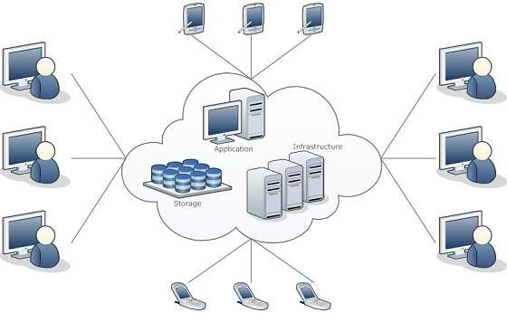

Cloud computing offers **platform independency,** as the software is not required to be installed locally on the PC. Hence, the Cloud Computing is making our business applications **mobile** and **collaborative.**

**Basic Concepts**

There are certain services and models working behind the scene making the cloud computing feasible and accessible to end users. Following are the working models for cloud computing:

* Deployment Models
* Service Models

**Deployment Models**

Deployment models define the type of access to the cloud, i.e., how the cloud is located? Cloud can have any of the four types of access: Public, Private, Hybrid, and Community.

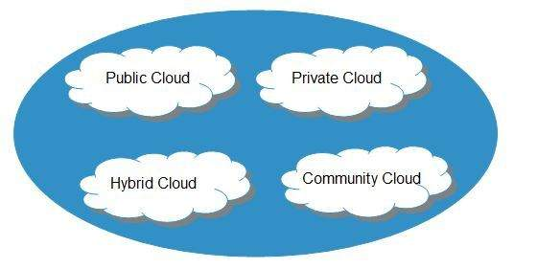

**Public Cloud**

The **public cloud** allows systems and services to be easily accessible to the general public. Public cloud may be less secure because of its openness.

**Private Cloud**

The **private cloud** allows systems and services to be accessible within an organization. It is more secured because of its private nature.

**Community Cloud**

The **community cloud** allows systems and services to be accessible by a group of organizations.

**Hybrid Cloud**

The **hybrid cloud** is a mixture of public and private cloud, in which the critical activities are performed using private cloud while the non-critical activities are performed using public cloud.

**Service Models**

Cloud computing is based on service models. These are categorized into three basic service models which are -

* Infrastructure-as–a-Service (IaaS)
* Platform-as-a-Service (PaaS)
* Software-as-a-Service (SaaS)

**Anything-as-a-Service (XaaS)** is yet another service model, which includes Network-as-a-Service, Business-as-a-Service, Identity-as-a-Service, Database-as-a-Service or Strategy-as-a-Service.

The **Infrastructure-as-a-Service (IaaS)** is the most basic level of service. Each of the service models inherit the security and management mechanism from the underlying model, as shown in the following diagram:

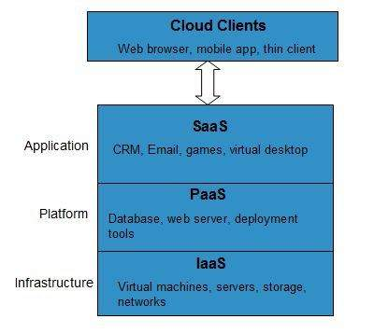

**Infrastructure-as-a-Service (IaaS)**

**IaaS** provides access to fundamental resources such as physical machines, virtual machines, virtual storage, etc.

**Platform-as-a-Service (PaaS)**

**PaaS** provides the runtime environment for applications, development and deployment tools, etc.

**Software-as-a-Service (SaaS)**

**SaaS** model allows to use software applications as a service to end-users.

**History of Cloud Computing**

The concept of **Cloud Computing** came into existence in the year 1950 with implementation of mainframe computers, accessible via **thin/static clients.** Since then, cloud computing has been evolved from static clients to dynamic ones and from software to services. The following diagram explains the evolution of cloud computing:

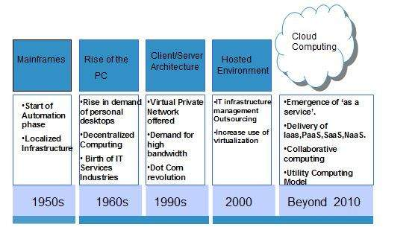

**Benefits**

Cloud Computing has numerous advantages. Some of them are listed below -

* One can access applications as utilities, over the Internet.
* One can manipulate and configure the applications online at any time.
* It does not require to install a software to access or manipulate cloud application.
* Cloud Computing offers online development and deployment tools, programming runtime environment through **PaaS model.**
* Cloud resources are available over the network in a manner that provide platform independent access to any type of clients.
* Cloud Computing offers **on-demand self-service.** The resources can be used without interaction with cloud service provider.
* Cloud Computing is highly cost effective because it operates at high efficiency with optimum utilization. It just requires an Internet connection
* Cloud Computing offers load balancing that makes it more reliable.

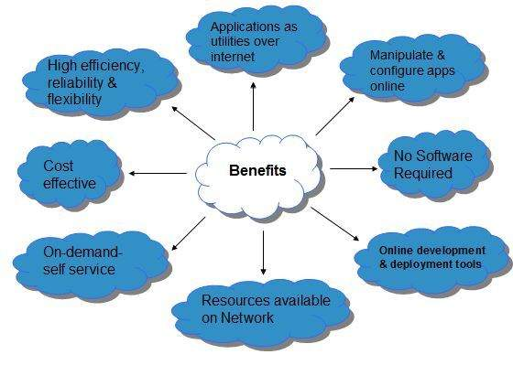

**Risks related to Cloud Computing**

Although cloud Computing is a promising innovation with various benefits in the world of computing, it comes with risks. Some of them are discussed below:

**Security and Privacy**

It is the biggest concern about cloud computing. Since data management and infrastructure management in cloud is provided by third-party, it is always a risk to handover the sensitive information to cloud service providers.

Although the cloud computing vendors ensure highly secured password protected accounts, any sign of security breach may result in loss of customers and businesses.

**Lock In**

It is very difficult for the customers to switch from one **Cloud Service Provider (CSP)** to another. It results in dependency on a particular CSP for service.

**Isolation Failure**

This risk involves the failure of isolation mechanism that separates storage, memory, and routing between the different tenants.

**Management Interface Compromise**

In case of public cloud provider, the customer management interfaces are accessible through the Internet.

**Insecure or Incomplete Data Deletion**

It is possible that the data requested for deletion may not get deleted. It happens because either of the following reasons

* Extra copies of data are stored but are not available at the time of deletion
* Disk that stores data of multiple tenants is destroyed.

**Characteristics of Cloud Computing**

There are four key characteristics of cloud computing. They are shown in the following diagram:

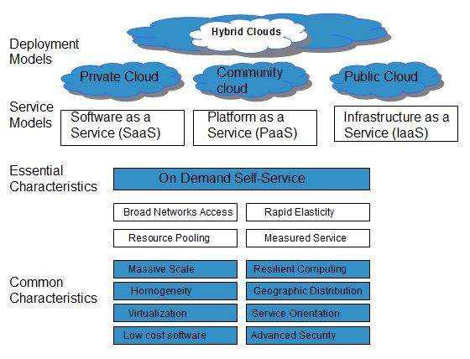

**On Demand Self Service**

Cloud Computing allows the users to use web services and resources on demand. One can logon to a website at any time and use them.

**Broad Network Access**

Since cloud computing is completely web based, it can be accessed from anywhere and at any time.

**Resource Pooling**

Cloud computing allows multiple tenants to share a pool of resources. One can share single physical instance of hardware, database and basic infrastructure.

**Rapid Elasticity**

It is very easy to scale the resources vertically or horizontally at any time. Scaling of resources means the ability of resources to deal with increasing or decreasing demand.

The resources being used by customers at any given point of time are automatically monitored.

**Measured Service**

In this service cloud provider controls and monitors all the aspects of cloud service. Resource optimization, billing, and capacity planning etc. depend on it.

Cloud Computing architecture comprises of many cloud components, which are loosely coupled. We can broadly divide the cloud architecture into two parts:

* Front End
* Back End

Each of the ends is connected through a network, usually Internet. The following diagram shows the graphical view of cloud computing architecture:

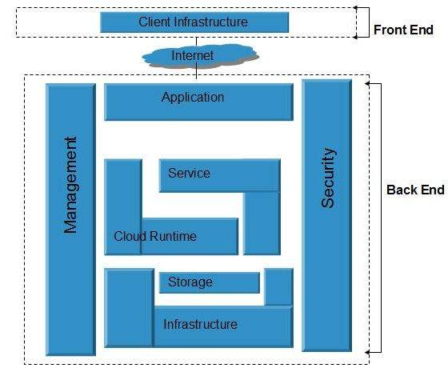

**Front End**

The **front end** refers to the client part of cloud computing system. It consists of interfaces and applications that are required to access the cloud computing platforms, Example - Web Browser.

**Back End**

The **back End** refers to the cloud itself. It consists of all the resources required to provide cloud computing services. It comprises of huge data storage, virtual machines, security mechanism, services, deployment models, servers, etc.

**Note**

* It is the responsibility of the back end to provide built-in security mechanism, traffic control and protocols.
* The server employs certain protocols known as middleware, which help the connected devices to communicate with each other.
* **Hybrid Cloud** is a mixture of **public** and **private** cloud. Non-critical activities are performed using public cloud while the critical activities are performed using private cloud. The Hybrid Cloud Model is shown in the diagram below.
* 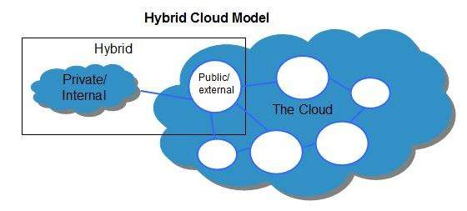

## Benefits

* There are many benefits of deploying cloud as hybrid cloud model. The following diagram shows some of those benefits:
* 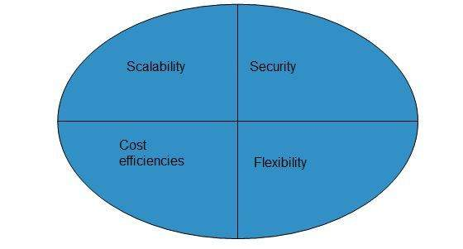

### Scalability

* It offers features of both, the public cloud scalability and the private cloud scalability.

### Flexibility

* It offers secure resources and scalable public resources.

### Cost Efficiency

* Public clouds are more cost effective than private ones. Therefore, hybrid clouds can be cost saving.

### Security

* The private cloud in hybrid cloud ensures higher degree of security.

## Disadvantages

### Networking Issues

* Networking becomes complex due to presence of private and public cloud.

### Security Compliance

* It is necessary to ensure that cloud services are compliant with security policies of the organization.

### Infrastructure Dependency

* The **hybrid cloud model** is dependent on internal IT infrastructure, therefore it is necessary to ensure redundancy across data centers.
* **Cloud infrastructure** consists of servers, storage devices, network, cloud management software, deployment software, and platform virtualization.
* 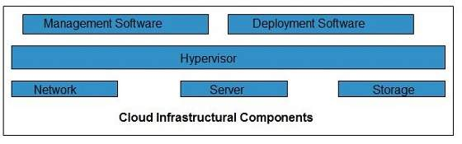

### Hypervisor

* **Hypervisor** is a **firmware** or **low-level program** that acts as a Virtual Machine Manager. It allows to share the single physical instance of cloud resources between several tenants.

### Management Software

* It helps to maintain and configure the infrastructure.

### Deployment Software

* It helps to deploy and integrate the application on the cloud.

### Network

* It is the key component of cloud infrastructure. It allows to connect cloud services over the Internet. It is also possible to deliver network as a utility over the Internet, which means, the customer can customize the network route and protocol.

### Server

* The **server** helps to compute the resource sharing and offers other services such as resource allocation and de-allocation, monitoring the resources, providing security etc.

### Storage

* Cloud keeps multiple replicas of storage. If one of the storage resources fails, then it can be extracted from another one, which makes cloud computing more reliable.

## Infrastructural Constraints

* Fundamental constraints that cloud infrastructure should implement are shown in the following diagram:

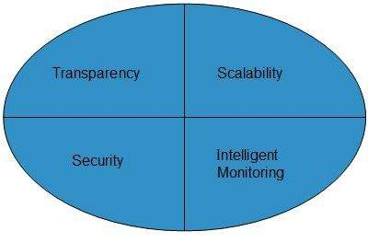

### Transparency

* Virtualization is the key to share resources in cloud environment. But it is not possible to satisfy the demand with single resource or server. Therefore, there must be transparency in resources, load balancing and application, so that we can scale them on demand.

### Scalability

* Scaling up an application delivery solution is not that easy as scaling up an application because it involves configuration overhead or even re-architecting the network. So, application delivery solution is need to be scalable which will require the virtual infrastructure such that resource can be provisioned and de-provisioned easily.

### Intelligent Monitoring

* To achieve transparency and scalability, application solution delivery will need to be capable of intelligent monitoring.

### Security

* The mega data center in the cloud should be securely architected. Also the control node, an entry point in mega data center, also needs to be secure.